



Introduction:

Before having a brief overview of the process and the slides, I would like to point out the fact that making a strategic decision on a business case usually requires a 360 degree view on the issue. Therefore, recommendations provided in this presentation might not necessarily apply to a real world problem without further investigations. For example, there is a suggestion to reduce purchases from some suppliers on specific products because their price is higher than the competitors. To actually make this decision, additional factors must be taken into account such as evaluating the supplier's entire portfolio rather than a single item, assessing the long-term strategic relationship with the supplier, recognizing that the quality of different sources may vary, trading rules between countries, shipment cost, and many more.

Also, considering the COO as the audience and applying the Pareto principle, we might not necessarily need to closely track all products at least for the top management, as some products have a negligible impact on the business outcome. To address this, I have categorized the products into three categories based on the amount of Euros we spend on them during the specified time period:

* **Top strategic products:** Products which the spending amount on them falls into the 95th percentile.
* **Strategic products**: products which the spending amount on them falls into the 90th percentile.
* **Non-Strategic products:** Any product below the 90th percentile.

Data processing:

* Since the unit price is in the local currency, all the purchase values used in the dashboards are already calculated in Euros for a more accurate comparison.
* **A data issue in the source:** I found that in the raw data, the week number is not tagged properly and it would cause calculation errors when it comes to pivoting the week numbers. Therefore, I retagged the week numbers.

Here is an example of the issue:

Below, at row number 12400 the date 07 June 2018 is tagged as week 25

Whereas, row number 11651 shows 20 June 2018 as week number 25 as well.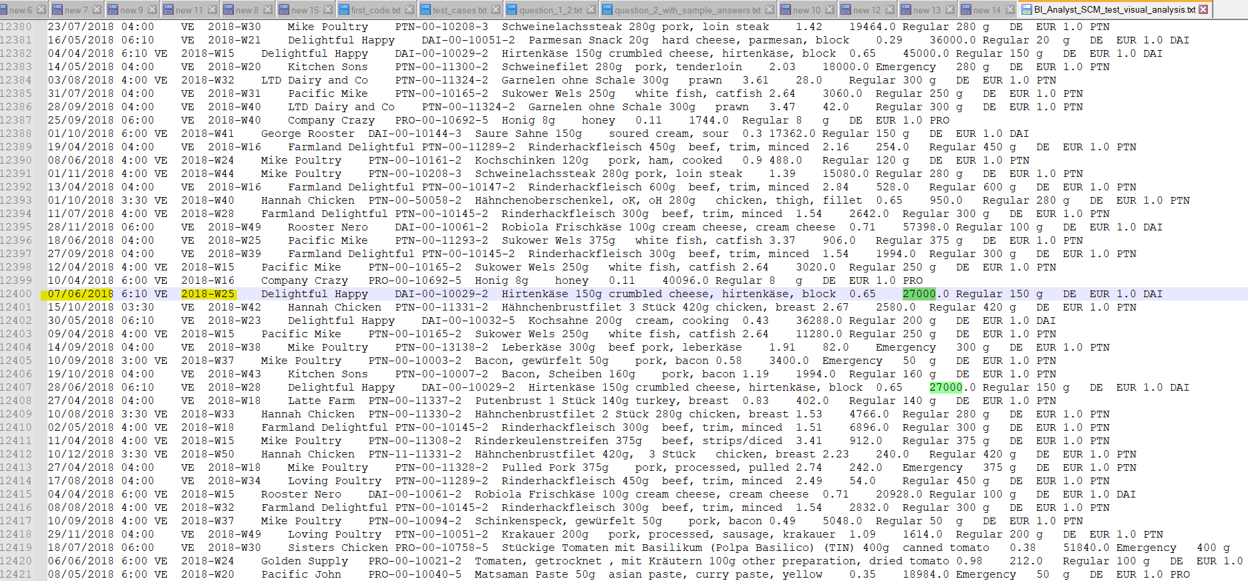

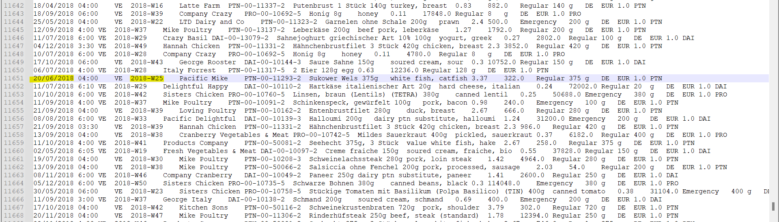

According to this website: <https://www.calendar-week.org/calendar-weeks/2018> week 25 in 2018 falls between 18 June and 24 June.

Also, The timezone wasn’t mentioned and I supposed all of the timestamps are in Central European Time, CET.

**What if the data will be continuously extended in the future?**

If the number of records increases, in the data pipeline we should handle concatenating the delta at the bottom of the dataset on a regular basis (if it is not a streaming pipeline).

In the dashboard layer, we have to make sure that the new years’ data can be automatically digestible by the dashboard and not only 2018 data. The dashboard should store the full date hierarchy so that when the user slices May’s data, they could also slice the proper year and quarter of it. It is so common among visualization tools to aggregate data based on a month no matter the year.

In case of schema change in the source, we might need to adjust the business logic, which is out of the scope of this document.

Design considerations:

From a product management point of view, for a dashboard as a BI product, the developer should focus on solving a problem of the stakeholder and making sure the users are able to easily navigate through and get what they want without confusion. Also, the numbers in all devices and screen sizes should be easily readable.

Finally, as a cherry on the top, I always add some elements to my dashboards to gamify the usage of the dashboard. For this reason, I use bright colors, high quality backgrounds, and shaded views to give it some depth and realistic feel. The bright and upbeat color scheme, along with accurate numbers makes a big difference in a dashboard.

I mostly tried to use the colors of HelloFresh palette for brand awareness and empowering the brand image even among internal users. The color codes are extracted from [THIS](https://www.hellofresh.de/pages/cook-this-big-idea?c=SD-MR1KU&gclid=CjwKCAjw-IWkBhBTEiwA2exyO4e_R2-SqNq_AxZoPYWWkZgqKagPjwchJt2r0YIPIWBcgY6ozQn0SxoC5bkQAvD_BwE) landing page.

Tooling:

Unfortunately, because of the short time in hand and my focus on delivering value instead of spending time reviewing Tableau which I used some years ago, I decided to use the latest tool I used for visualization; PowerBI for this project, but once I am in the position I can be equally comfortable using Tableau surely.

Now, it is time to navigate through the dashboard screenshots on the slideshow.

Insight One:

1.Price fluctuations & potential saving opportunities

Prices per gram of similar products differ from supplier to supplier. It gives us an opportunity to save costs by trying to put more budget into cheaper sources and by doing so, we are expecting the overall costs of our raw materials to decrease and eventually the company saves funds on ingredient purchases.

**1.1 Recommended actions based on the dashboard:**

* Comparing the price per gram of each product and SKU unit clearly shows that we can try to optimize the purchase budget allocation by ordering more from sources with cheaper price per gram.

A metric has been generated named “Saving Estimation per 0.001€ ” which shows if on each SKU we could save only 0.001€ per gram, how much we could have saved in the past 6 months. This shows the business impact to the user and convinces them to take action if the saving amount is remarkable.

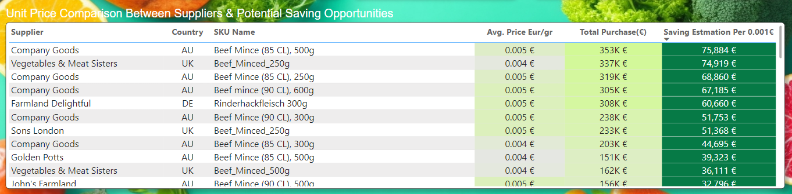

* The second heatmap, can help the user to understand how the price of specific products fluctuate over time for a supplier, compared to the other suppliers who offer the same products. Using this view, the business user can find in which months of the year, which supplier has a cheaper price on each product and try to increase the purchase amount from them.

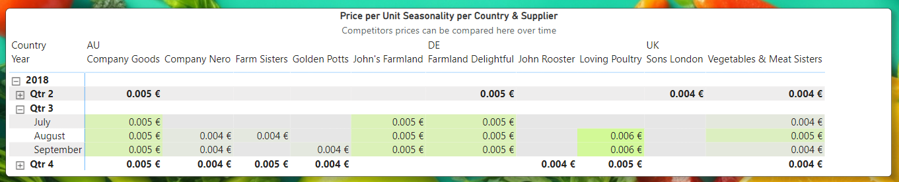

**1.2 Who can use this dashboard?**

Both of the charts can be used by the C-suite by rolling up the rows from months to quarter and year, and rolling up from supplier to country. Having the bigger picture in mind, the COO can decide on strategic portfolio adjustments for each supplier and hopefully it is expected that these heatmaps help them make better decisions.

The charts can be drilled down to weeks as time dimension, and SKU names from the product side, in order to show more granular level data to middle managers to be able to run the operations team.

2. Insight Two:

There is risk of monopoly among some suppliers

From the strategic point of view, it puts the business at risk to give monopoly to a supplier on a product, especially if the product is a top-strategic one. As a proof of this insight, the product named “chicken, thigh, filet” is a top strategic product and 99.91% of it is supplied by “Poultry LTD.”

**2.1 Recommended actions based on the dashboard:**

The COO should actively try to increase the supply chain resiliency by having multiple sources available for each strategic product. It is recommended to bring in more suppliers or negotiate with other suppliers with a similar portfolio to include this product in theirs as well. It puts the business in a higher position and bargaining power in negotiations.

As the next iteration of the project it might be helpful to write a query to calculate the resilience factor for each product, which simply shows the manager in percentage, how much risk is

involved in each product’s supply based on the number of available sources and reliability of each.

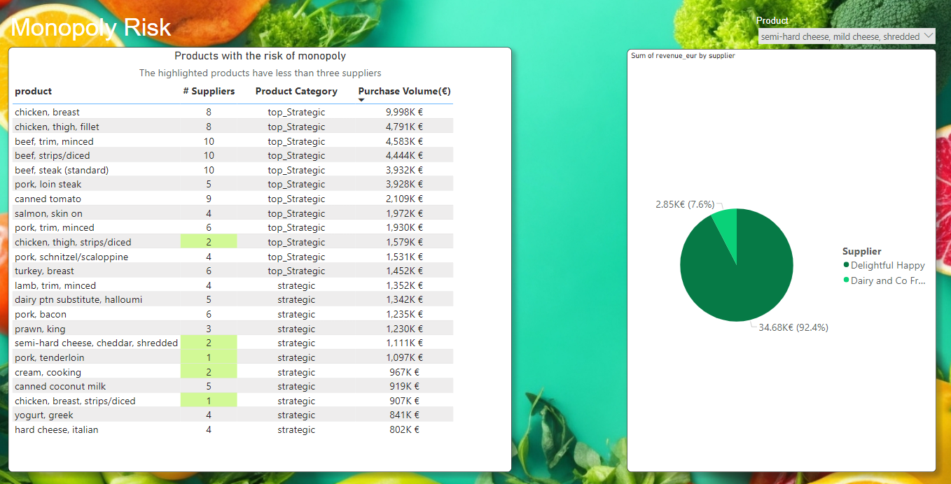

**2.2 Who can use this dashboard?**

This chart can be used by all audiences, although it seems like the COO could be more interested in this topic.

3. The COO Dashboard:

Top level snapshot of the business to help the C-level make strategic decisions

It is important for the managers to know what products are strategic and why. The following view shows what products have the biggest impact on the business by showing the total investment we have on each product based on the raw data.

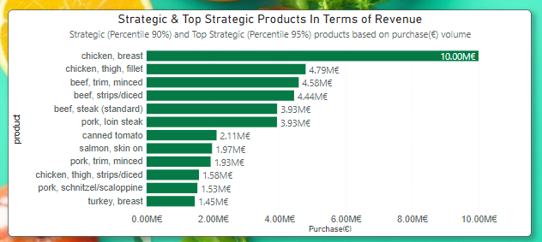

Also, market share of each supplier in total and per product should be tracked by the management.

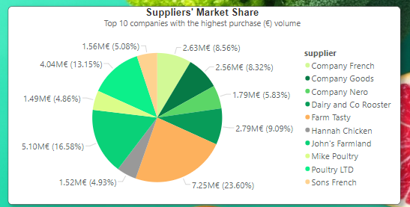

**Note:** Because the top management is usually not interested in too granular information, only top-strategic and strategic products are used for this dashboard.

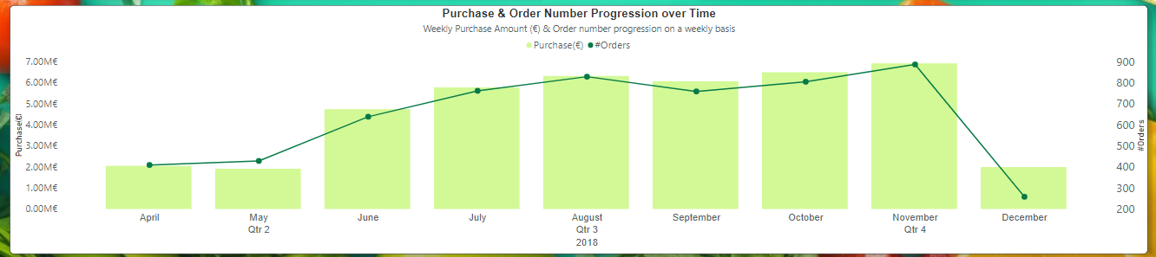

A manager must be interested in the volume of orders in terms of spending, frequency of deliveries, and weight per country and year or quarter. The following chart can show the development of the purchase value and order frequency per year, quarter, and month. It can also be sliced per product and supplier.

Slicers on this dashboard assist the users to slice and dice information based on different countries, products, and suppliers.

**Note:** Slicers are set up to slice the views that are relevant. Therefore, not all views get sliced by all slicers.

4. Product Portfolio Analysis Dashboard:

A dashboard to track the products and SKU distribution and delivery timeline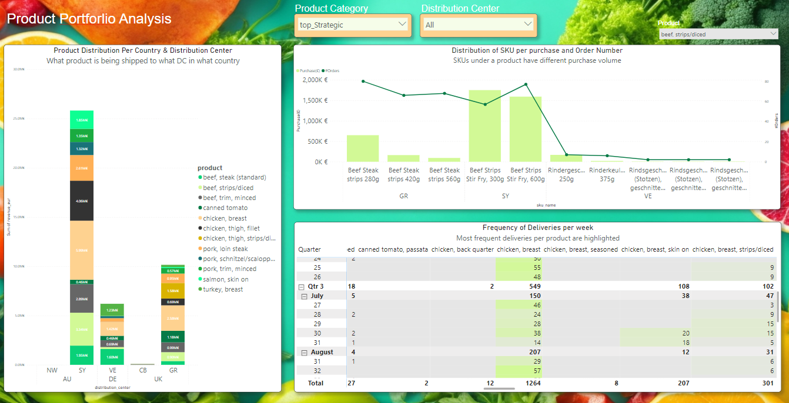

**4.1 Business Impact:** The middle managers can get an overview of what products are being delivered in what places and when they are being delivered. It also helps them visually comprehend what products are delivered to what DC.

**4.2 Actions recommended to improve efficiency:** It is recommended to the middle operations management to track their KPIs using these charts. For instance, A KPI could be replacing 20% of “chicken breast” weekly deliveries with “chicken breast, skin on” for the next three months as some end customers don’t mind skin on the breast. This dashboard can give them a good understanding of the current situation, and of course the cumulative KPI achievement and forcast views will be needed to track the KPI and help them achieve it before the deadline.

5. Delivery Management Dashboard:

A dashboard to give an overview of what product is going to be delivered on what DC, what day or time of the week, and how frequently

**5.1 Business Impact:** The middle managers can use the slicers to find the exact delivery schedule of a specific product. For example the below view means: “Beef Steak (standard)” is going to be delivered twice a day on week 24 into two different DCs (SY & VE) between Tuesday to Friday almost at 6:00AM and 12:00AM with a few exceptions. The total deliveries will be 12 times and 37 tons will arrive.

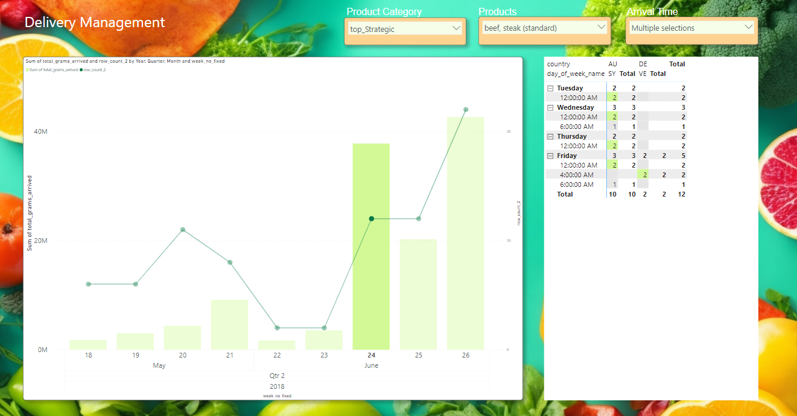

**5.2 Who can use this dashboard?**

This dashboard is more suitable to middle operation managers and not the top management.

6. Conclusion, what comes next?

Some additional thoughts

As the next steps of the dashboard enrichment process, some of thoughts below could be helpful:

* Finding what products have a regular delivery timeline vs which ones are more spontaneously delivered. This view may help the procurement staff to be prepared for spontaneous deliveries.
* Mapping this data with some order information, we might be able to see what suppliers could successfully deliver on an emergency with the shortest notice and closest price to regular deliveries. It can help us calculate a reliability score for the suppliers.
* To further analyze the procurement and recommend more efficiency boosters, we can come up with more ideas if we have the data about what products expiration dates are, which ones should be used as fresh as possible and which ones can be on the shelves for a while, combined with the inventory system data, to be able to further fine tune the purchases and portfolio development, and reduce the warehousing cost.

Thank you for your attention!